**Description**

As a admin I must have ability to see my dashboard.

As a admin I must see left navigation panel with following options

1. Restaurant Settings
2. Site Pages
3. Menu Categories
4. Contact us Inbox
5. Account settings

------------------------------------------------------------------------------------------------------------------------------------------

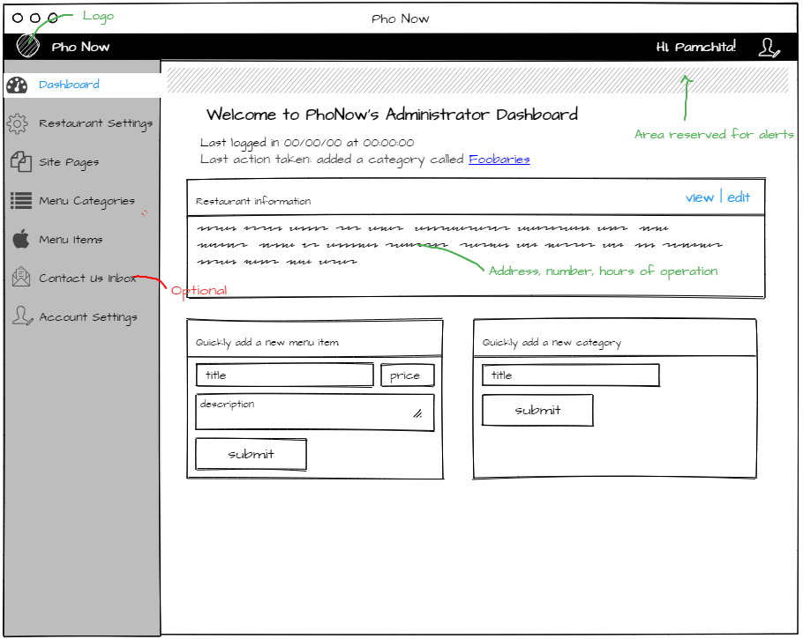

**Acceptance criteria**

* Displays Dashboard page with all the options
* All options are enabled
* Ability to edit each option based upon user role